**ACTIVITY 1**

**Individual work !**

1. Draw the DOM tree for the HTML code below :

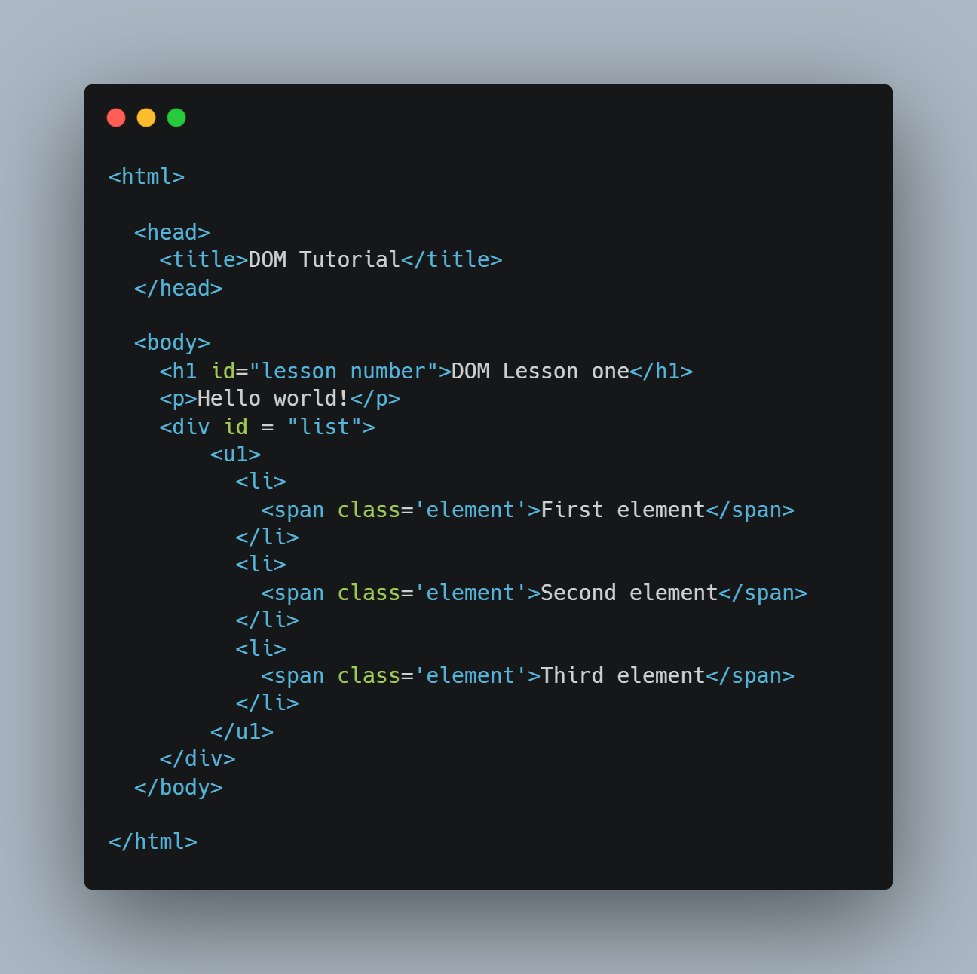

1. **Answer the questions :**

|  |  |
| --- | --- |
| How many **children** does the <h1> node have | There is one children |
| How many **children** does the <head> node have | There is one children |
| How many **siblings** does the first <li> node have | There are three siblings |
| Who is the **parent** of the second <span> node | Li is the parent of the second <span> |
| Who is the **parent** of the <ul> node | The parent of the <ul> is div |
| Who is the **first child** of the <body> node | The first child of the <body> is h1 |
| How many **children** does the <body> node have | There are three children in <body> |
| How many **siblings** does the <ul> sibling have | There are three siblings that <ul> sibling have |
| What is the **root** **node**, does it have parents | RootNode is the HTML element from which to start recursively searching the hierarchical DOM tree. It don’t have parents. |